CONTEMPORARY WORLD

# The Silk Road: A Global Trade Pioneer

**1st Century – 5th Century AD -** Luxury goods from China, like silk, began appearing in Rome, marking the start of long-distance trade.

**13th-14th Centuries AD -** The Silk Road reopened under the Mongol Empire, demonstrating the importance of political stability for trade.

# Spice Routes (7th-15th Century): A Maritime Trade Network

**Islamic Merchants -** Islamic merchants dominated Mediterranean and Indian Ocean trade, spreading their influence and trade networks.

**Spice Islands -** The Spice Islands, in Indonesia, became a major source of cloves, nutmeg, and mace, driving international trade.

**Luxury Trade -** Spices, like silk, remained luxury goods, with high demand but limited volume, hindering true globalization.

# The Age of Discovery (15-18th centuries): A New Era of Global Trade

**European Exploration -** European explorers connected East and West, discovering new lands and resources.

**Columbian Exchange -** The discovery of America led to the exchange of goods and ideas, impacting both continents.

**Magellan's Circumnavigation -** Magellan's voyage opened direct trade routes to the Spice Islands, bypassing middlemen.

# The First Wave of Globalization (19th century): Industrialization and Trade

**British Dominance -** Britain's industrial revolution fueled global trade, with steam ships and trains facilitating transportation.

**Global Trade Growth -** Trade grew rapidly, with exports reaching 14% of global GDP by the eve of World War I.

**Global Investment -** International investment flourished, with companies building infrastructure and managing resources globally.

**Specialization and Trade -** Countries specialized in their most competitive industries, leading to a more interconnected global economy.

# The World Wars: A Setback for Globalization

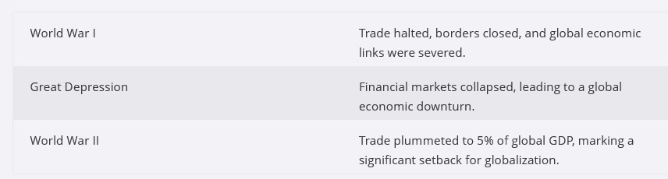

**The Second and Third Waves of Globalization: A Resurgence of Trade**

**Post-War Recovery -** Trade rebounded after World War II, driven by institutions like the European Union and the WTO.

**Global Integration -** The fall of the Iron Curtain and China's entry into the WTO led to a truly globalized economy.

**Digital Revolution -** The internet facilitated global communication and trade, further integrating value chains.

**Economic Growth -** Global exports reached a quarter of global GDP, benefiting many and creating a global middle class.

# Globalization 4.0: A New Era of Digital and Environmental Challenges

**Digital Economy -** E-commerce, digital services, and AI are driving a new wave of globalization, with both opportunities and challenges.

**Climate Change -** Pollution and deforestation have global consequences, impacting the environment and exacerbating inequality.

**Backlash Against Globalization -** Many are turning away from globalization, citing economic inequality, social instability, and political polarization.

**The Future of Globalization -** The future of globalization remains uncertain, with both opportunities and challenges shaping its trajectory.

# Globalization: A Complex and Interconnected World

**Globalization** is a multifaceted phenomenon that has profoundly shaped our world. It

encompasses the interconnectedness of people, countries, and economies, driven by the flow of goods, services, finance, people, and ideas.

**World Health Organization (WHO) -** Globalization is defined as the increased interconnectedness and interdependence of peoples and countries.

**Thomas Friedman** - Globalization is the inexorable integration of markets, transportation

systems, and communication systems, enabling corporations, countries, and individuals to reach around the world farther, faster, deeper, and cheaper than ever before.

**Committee for Development Policy -** Globalization, from an economic perspective, is the increasing interdependence of world economies due to cross-border trade, international capital flow, and technological spread.

**Manfred Steger's Definition** - expansion and intensification of social relations and consciousness across world-time and world-space.

**IMF Definition of Economic Globalization:**

* A historical process driven by human innovation and technological progress.
* Involves increasing integration of economies through cross-border movement of goods, services, and capital.
* Defined by a mix of objective and subjective factors.

**United Nations Definition of Economic Globalization:**

* Describes globalization as growing interdependence of world economies via trade, capital flow, and rapid technology spread.
* Views globalization as an irreversible trend for global economic development.
* Driven by market expansion and increasing importance of information in productive activities.

**Global Trade:**

* Emerged when all populated continents started exchanging goods continuously, creating lasting economic impacts (Flynn & Giraldez).
* Manila Galleon Trade: First global trade connecting the American continent to Asian trade routes, facilitating exchange of goods, people, and ideas between East and West.

**Trade Conflicts:**

* Global trade can lead to political and economic conflicts between countries due to differences.
* Unresolved trade conflicts in the past have led to wars and economic downturns.
* Economic interdependence makes global markets susceptible to conflicts or economic crises in individual countries.

**Global Actors in Economic Globalization:**

* Numerous institutions facilitate economic globalization to maintain global economic stability.
* These actors also contribute to global political processes.

**Role of the United Nations (UN):**

* An international organization focused on diplomacy, peace, and security.
* Aims to foster international cooperation and coordinate actions among its 193 member nations (as of 2024).
* Plays a critical role in maintaining global political and economic stability.

**Specialized Agencies**

**International Labor Organization (ILO)**

* Deals with labor issues, international labor standards, social protection, and work opportunities.

**Food and Agriculture Organization (FAO)**

* Defeats hunger, combats food insecurity and malnutrition.
* Reduces rural poverty and promotes sustainable agriculture, forestry, and fisheries.
* Builds resilience against threats and crises.

**United Nations Educational, Scientific and Cultural Organization (UNESCO)**

* Promotes peace and security via international collaboration in education, science, and culture.
* Advocates for justice, human rights, and freedom.

**World Health Organization (WHO)**

* Focuses on public health, disease eradication (e.g., AIDS/HIV), and vaccine research.
* Publishes the World Health Report and conducts health surveys.

Other Specialized International Institutions:

**International Civil Aviation Organization (ICAO)**

* Ensures safe, orderly growth of international air transport.

**International Maritime Organization (IMO)**

* Focuses on maritime safety, security, and pollution prevention.

**International Telecommunication Union (ITU)**

* Enhances global communications, manages radio spectrum, satellite orbits, and improves ICT access.

**Universal Postal Union (UPU)**

* Regulates international mail exchanges and improves postal services globally.

**World Meteorological Organization (WMO)**

* The UN's authority on meteorology, climate, and water resource distribution.

**World Intellectual Property Organization (WIPO)**

* Manages intellectual property (patents, trademarks, copyright) to promote innovation and creativity.

**International Fund for Agricultural Development (IFAD)**

* Empowers rural populations, improving food security, nutrition, and income.

**United Nations Industrial Development Organization (UNIDO)**

* Promotes industrial development for poverty reduction, inclusive globalization, and sustainability.

**World Tourism Organization (UNWTO)**

* Promotes responsible, sustainable, and accessible tourism for economic growth and environmental sustainability.

**OTHER GLOBAL ACTORS**

**Multinational Corporation (MNC)**

* Economic Globalization and Global Production:
* Goal of Companies: Seek efficient and maximized profits through global production involving many regions.
* Global Networks: New technologies enhance the movement of information, goods, services, and people, fostering global free trade and capital flow.
* Interconnected Production: Various stages of production occur in different locations, depending on factors like cheap labor, raw materials, skilled labor, and market conditions.
* Business Organizations:
* Operate in more than two countries, driving foreign direct investment (FDI) by establishing subsidiaries globally (Lazarus, 2001).

**World Trade Organization (WTO):**

* The only global organization dealing with trade rules between nations.
* Manages trade agreements, resolves disputes, and promotes smooth, predictable, and free global trade.
* Supports developing countries.

**World Bank:**

* Financial institution providing loans to countries for economic improvement.
* Primary Function: Focused on long-term economic development and poverty reduction in developing countries.

**World Bank Group:**

* **IBRD**: Offers loans to middle-income countries.
* **IDA**: Provides loans to developing nations for reducing inequality.
* **IFC**: Supports private sectors in developing countries.
* **MIGA**: Promotes FDI to help economic growth in developing countries.
* **ICSID**: Facilitates dispute settlements for investors and nations.

**International Monetary Fund (IMF):**

* Founded at the Bretton Woods Conference in 1944 to promote international monetary cooperation.
* Provides research, advice, and monetary consultations, especially with less-developed and developed countries.
* Overseeing the international monetary system and ensuring its stability

**THE DIIFFERENCE BETWEEN IMF AND WORLD BANK**

**Focus**: The World Bank primarily focuses on long-term development and poverty reduction, while the IMF focuses on short-term financial stability and crisis prevention.

**Type of Assistance:** The World Bank provides loans and grants for infrastructure and development projects, while the IMF provides short-term loans and policy advice to countries facing financial difficulties.

**Global Alliances and Agreements:**

**North Atlantic Treaty Organization (NATO):**

* Formed in 1949, headquartered in Brussels, aims for collective defense against attacks on member nations.
* The organization was originally formed out of the fear that the Soviet Union would ally military with Eastern European nations i.e. the Warsaw Pact, and thus become a threat to Western Europe and the United States.

**Organization for Economic Cooperation and Development (OECD)**

* Membership: 35 member states (as of 2016)
* Influence: Highly influential despite little formal power.
* Reason: Member countries' resources and economic power.

**Organization of Petroleum Exporting Countries (OPEC)**

* Purpose: Formed to increase oil prices.
* Members: Saudi Arabia, Iraq, Kuwait, Iran, Venezuela (original members); United Arab Emirates, Algeria, Libya, Qatar, Nigeria, Indonesia (added later).

**European Union (EU)**

* Membership: 28 member states.
* Currency: Euro (adopted by most members, but not Great Britain, Sweden, or Denmark).
* Criticism: Critics argue that the euro increased prices, depressed economic growth rates (e.g., Greece, Spain, Portugal), and that the European Central Bank's policies contributed to these issues.

**North American Free Trade Agreement (NAFTA)/United States-Mexico-Canada Agreement (USMCA)**

* Purpose: Trade pact between the United States, Mexico, and Canada.
* Creation: 1989 (Canada and United States), 1994 (Mexico added).
* Replacement: USMCA replaced NAFTA in 2020.
* Benefits: Creates a more balanced trade environment, supports high-paying jobs, and grows the North American economy.

Economic Globalization and Global Economy Perspectives:

Global Actors in Economic Globalization:

Significant contributors to economic globalization include international organizations and regimes like the World Bank, IMF, WTO, and ILO.

Regional integration schemes (e.g., EU, NAFTA) play a key role in establishing rules and norms in the global economy.

### Globality, Globalism, and Their Types

1. **Globality -** Globality signifies a future social condition characterized by thick economic, political, and cultural interconnections, making existing political borders and economic barriers irrelevant.
2. **Globalism -** Globalism refers to globalization as an ideology reflecting shared ideas, norms, and values accepted as truth.
   * **Market Globalism -** Advocates for a consumerist, neoliberal, free market world, claiming it transmits democracy and benefits everyone. However, it can reinforce inequality and be politically motivated.
   * **Justice Globalism -** Envisions a global civil society with fairer relationships and environmental safeguards, disagreeing with market globalists who view neoliberalism as the only way.
   * **Religious Globalism -** Strives for a global religious community with superiority over secular structures.

### Multiple Globalizations

**Arjun Appadurai**, an anthropologist, proposed the concept of **"multiple globalizations**," arguing that different kinds of globalization occur on multiple and intersecting dimensions of

integration, which he calls **"scapes."** These scapes include the **enthnoscape** (global movement of people**), mediascape** (flow of culture), **technoscape** (circulation of mechanical goods and

software), **finanscape** (global circulation of money), and **ideoscape** (realm of political ideas).

### Making Globalization More Just

While globalization has brought unprecedented economic wealth and scientific progress, it has also led to inequality and environmental costs. To make globalization more just, we need to address these issues by designing fairer

societies and a healthier planet. This requires global consensus, country-specific solutions, and a clear definition of "just

**Levels of Global Economy (According to Gereffi):**

**Macro Level:**

* Focuses on international organizations and regimes that set global rules.
* Includes entities like the World Bank, IMF, WTO, EU, and NAFTA.
* Mga Global Actors

**Meso Level:**

* Global economy viewed as a competition between countries and firms in product markets
* Examines countries and firms as the building blocks of the global economy.
* Views the global economy as a competitive arena for countries.

**Micro Level:**

* Resistance to globalization by consumer groups, activists, and social movements. Focus on how economic sociology incorporates the global economy and its influence on actors' behavior.
* Considers different theories about the global economy's influence on individual behavior and interactions.

##### Gereffi has proposed that the global economy can be examined from various perspectives.

* + **MACRO** - global actors establish rules and norms for the global community
  + **MESO** - global economy is seen as the arena in which countries compete in different product market.
  + **MICRO** - global economy is seen as an arena where nations are determined where nationally determined actors meet, interact and influence each other.

The **Modern World System (MWS) theory,** developed by **sociologist Immanuel Wallerstein,** offers a framework for understanding the historical development and dynamics of the global economy.

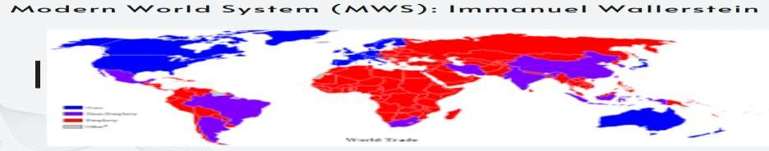

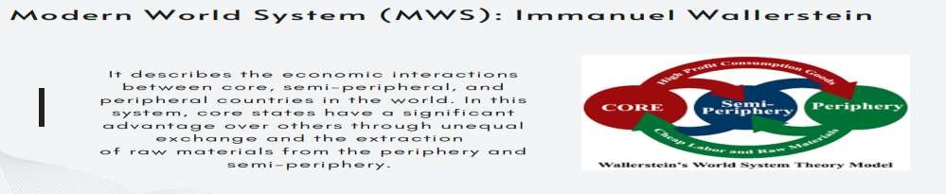

**Core, Semi-Periphery, and Periphery**

The **global economy is stratified means** divided into layers or classes. It's often used to describe something that is arranged or organized in a hierarchical or layered way.

* **Core countries** - dominate and exploit peripheral countries.
* **Peripheral countries** - provide raw materials, with wealth flowing from the periphery to the core.
* **Semi**-**peripheral** - countries serve as intermediaries.

**Core countries benefit** from unequal exchanges and resource extraction from periphery and semi-periphery.

**Example of Core-Periphery Relationship: Philippines**

**Core Country**: United States

**Peripheral Country**: Philippines

**Semi-Peripheral Country**: South Korea

Scenario:

**Resource Extraction**: The Philippines, rich in natural resources like copper and gold, exports these to the United States.

**Manufacturing**: The United States processes these raw materials into finished products, such as electronics and jewelry.

**Economic Flow**: Wealth flows from the Philippines (periphery) to the United States (core) as the Philippines sells its raw materials at a lower price than the finished products.

**Semi-Peripheral Role**: South Korea, with a developing economy, may import raw materials from the Philippines and export manufactured goods to the United States. It benefits from both the core and periphery, serving as an intermediary.

**Key Points**:

The United States, as a core country, controls the value chain and benefits from the added value created through manufacturing.

The Philippines, as a peripheral country, is dependent on the export of raw materials and receives a smaller share of the value generated.

South Korea, as a semi-peripheral country, benefits from its position between the core and periphery, but may still be subject to exploitation by the core.

#### CORE COUNTRIES

* + Exert control and utilize resources and labor to those on the periphery
  + Industrialized capitalist counties
  + Mostly dominant countries

#### SEMI-PERIPHERY

* + Semi-periphery countries share both characteristics of core and peripheral countries
  + They are rich countries but with limits as well

#### PERIPHERY

* + Less develop countries
  + Typically provides raw materials and cheap labor
  + Economically and politically dependent to CORE countries
* Modern World System Theory believed that this division creates a system where wealth flows from the less developed to the more developed

regions, maintaining global inequality.

* It was during the **Treaty of Westphalia on 1648** where the notion of nation- state and idea of state sovereignty has started. Today, the globalization of politics created an atmosphere where the ideas of the nation-state, state sovereignty, government control, and state policies are challenged from all sides.
* The following are suggested “replacements” for nation-states: 1. regional alliances and worldwide organizations 2. regional and international

economic bonds 3. private capital groups 4. non-state organizations

**Balaamand Veseth, 2008)-**Economic globalization and 21st-century market integration are extensions of imperial motives from the 19th and 20th centuries.

**State and Sovereignty:**

* State: The traditional subject of global politics, consisting of: Fixed territory, people, government, and sovereignty.
* State sovereignty is the principle that a state has the supreme authority within its own territory, meaning it is independent from external control and has the right to govern itself without interference from other states. This includes the power to make laws, conduct foreign policy, and maintain an army.

**Treaty of Westphalia (1648):**

* Established the concept of state sovereignty and the nation-state.

**Globalization’s Challenge to the State:**

Nation-state, sovereignty, and government control face challenges from:

* Regional alliances and worldwide organizations.
* Regional and international economic bonds.
* Private capital groups.
* Non-state organizations.

**Interstate System and Global Hierarchies:**

* **Sovereignty**: Traced back to the Treaty of Westphalia, which ended the Thirty Years' War (1648).
* **Challenges**: Faced major challenges during Napoleon’s spread of liberty, equality, and fraternity.

Despite the collapse of systems like the Concert of Europe (after WWI), the current international system still reflects traces of this history.

**World-Systems Perspective:**

* Focus on global interdependence and stratification (core-periphery hierarchy).
* Core nations hold more power and wealth than peripheral nations.

**Global Power and Decolonization:**

**World-Systems Theory and the Global South:**

* Emerged from the world revolution of 1968 and the anti-war movement.
* Recognized that the Global South (formerly the "Third World") played an active role in its own liberation.
* Colonialism and decolonization shaped global systems and power structure.

# INTERSTATE SYSTEM

* Refers to the political and diplomatic relationships between sovereign nation-states within the international arena.

The interstate system or world-systems perspective on modernity claims that this high degree of interdependence is not a recent phenomenon and that an

important dimension of the global system has been, and continues to be, its stratification structure that is organized as a core/periphery hierarchy in which some national societies have far more power and wealth than others.

# Effects of Globalization on Governments

* + Globalization is seen to impose a forced choice upon nation-states.
  + establishment of economic and political integrations.
  + the establishment of international laws and principles.
  + the rise of transnational activism (TNA). Such happens when activist groups of nation-states connect with their counterparts in other states

## LESSON 3: THE GLOBAL ECONOMY

##### The International Monetary Fund (IMF)

* regards “economic globalization‟ as a historical process representing the result of human innovation and technological progress. It is characterized by the increasing integration of economies around the world through the movement of goods, services, and capital across borders.

##### Dennis O. Flynn and Arturo Giraldez

* Global trade emerged when 1) all heavily populated continents began to exchange products continuously - both with each other directly and indirectly via other continents

- and 2) did so in values sufficient to generate lasting impacts on a ll trading partners” (Globalization Began in 1571.p2).

## GLOBAL ACTORS

**MULTINATIONAL CORPORATIONS (MNCs)** - It is a business organization located in more than two countries and is the organizational firm defining foreign direct investment. This firm consists of a country location where it is incorporated and established branches or subsidiaries in foreign countries (A.A Lazarus, 2001 p10197).

**World Trade Organization (WTO), International Monetary Fund (IMF), and the World Bank**

### WTO agreements:

* The goal is to ensure that trade flows smoothly, predictably, and freely. It has many roles: it operates a global system of trade rules, acts as a forum for negotiating trade agreements, settles trade disputes between its members, and supports the needs of developing countries.

### The International Monetary Fund (IMF)

Its primary purpose is to ensure the stability of the international monetary system—the system of exchange rates and international payments that enables countries (and their citizens) to transact with each other.

**World Bank** is a vital source of financial and technical assistance to developing countries

around the world that provides low-interest loans, zero to low-interest credits, and grants to developing countries.

**North Atlantic Treaty Organization (NATO) -** based on the North Atlantic Treaty, which provides the organization a framework. The treaty provides that an armed attack against one or more of NATO’s member nations shall be considered an attack against them all. It is

headquartered in Brussels, Belgium. The organization was formed in 1949. Many countries joined NATO -- even Iceland which is the only member without a military force. The organization was originally formed out of the fear that the Soviet Union would ally military with Eastern European nations i.e. the Warsaw Pact, and thus become a threat to Western Europe and the United States

**Organization for Economic Cooperation and Development -** The most encompassing club of the richest countries in the world is the Organization for Economic Cooperation and Development (OECD) with 35 member states as of 2016, with Latvia as its latest member. It is highly influential, despite the group having little formal power. This emanates from the member countries‟ resources and economic power.

**Organization of Petroleum Exporting Countries (OPEC) -** In 1960, the Organization of Petroleum Exporting Countries (OPEC) was originally comprised of Saudi Arabia, lraq, Kuwait,

Iran, and Venezuela. They are still part of the major exporters of oil in the world today. OPEC was formed because member countries wanted to increase the price of oil, which in the past had a relatively low price and had failed in keeping up with inflation. Today, the United Arab Emirates, Algeria, Libya, Qatar, Nigeria, and Indonesia are also included as members.

The **European Union (EU)** - The European Union (EU) is made up of 28 member states. Most members in the Eurozone adopted the euro as basic currency but some Western European nations like the Great Britain, Sweden, and Denmark did not. Critics argue that the euro increased the prices in Eurozones and resulted in depressed economic growth rates, like in Greece, Spain, and Portugal. The policies of the European Central Bank are considered to be a significant contributor in these situations.

**North American Free Trade Agreement (NAFTA**) - The North American Free Trade

Agreement (NAFTA) is a trade pact between the United States, Mexico, and Canada created on January 1, 1994 when Mexico joined the two other nations. It was first created in 1989 with only Canada and the United States as trading partners. NAFTA helps in developing and expanding world trade by broadening international cooperation. It also aims to increase

Cooperation for improving working conditions in North America by reducing barriers to trade as it expands the markets of the three countries

**LESSON 4**

**Market Integration**

**Market Integration** is the process where different markets begin to operate in unison, particularly in how prices behave over time. When prices of related goods or services across different locations follow similar trends, it indicates that the markets are integrated. Market integration can lead to increased efficiency and a more uniform market environment.

**Types of Market Integration**

1. **Horizontal Integration**
   * **Definition**: Occurs when a firm or agency gains control over other firms performing similar functions at the same level of the value chain (marketing sequence).
   * **Mechanism**:
     + Firms combine to reduce competition and create a unified strategy, often resulting in a reduction in the number of firms in the market.
     + This strategy is used by firms to achieve **economies of scale**, enhance **market power**, and **increase market share** by acquiring competitors.
   * **Example**:
     + **Mergers and Acquisitions**: Two firms combine either through acquisition (one company buys another) or a merger (two firms join as equals).
     + Example: Disney acquiring **Pixar** and **Miramax** were examples of horizontal integration. These moves helped Disney expand its dominance in the entertainment industry.

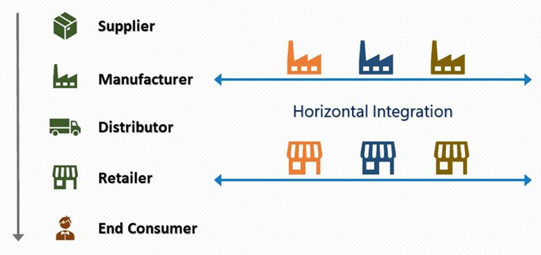

* + **Advantages**:
    - **Cost reduction** through economies of scale.
    - **Market power** over suppliers and distributors.
    - **Increased product differentiation** and potential to enter new markets.
  + **Disadvantages**:
    - **Reduced competition** in the industry, which may harm consumers by reducing choices or raising prices.
    - **Risk of monopolization**.
  + **Industry Examples**:
    - **Oil Industry**: Large oil company mergers like **Exxon and Mobil** in 1999 or **Chevron and Texaco** in 2001 were aimed at improving efficiency in costly processes like oil exploration and refining.
    - **Food Industry**: Kraft’s acquisitions of **Nabisco** in 2000 and **Cadbury** in 2009 allowed the company to expand its global reach in the confectionery sector.

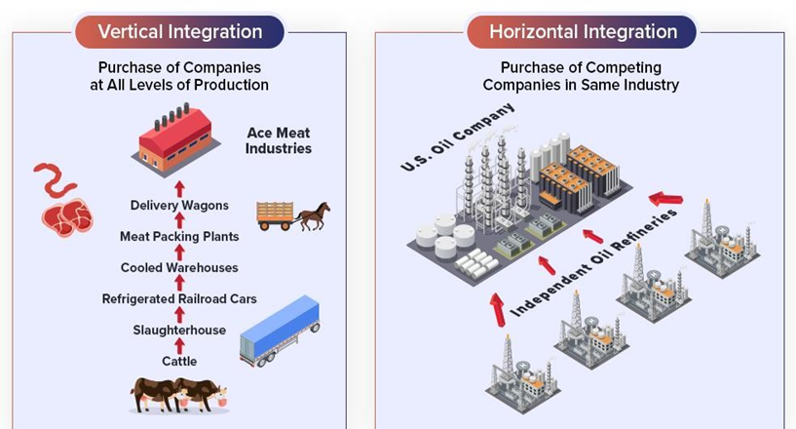

1. **Vertical Integration**
   * **Definition**: Occurs when a firm expands its control over multiple stages of production or distribution within the same industry. This reduces the role of intermediaries in the supply chain.
   * **Mechanism**:
     + A firm may integrate **backward** by controlling its suppliers or **forward** by gaining control over its distribution or retail channels.
     + This strategy can help firms **increase control over supply chains**, **reduce costs**, and **enhance efficiency**.
   * **Example**:
     + **Tesla**: By building its **Gigafactory** to produce batteries, Tesla is pursuing vertical integration by controlling the production of a key component of its electric vehicles, reducing reliance on external suppliers like Panasonic.
     + **PayPal**: By becoming a payment provider, PayPal eliminated intermediaries and now handles transactions directly between consumers and retailers.
   * **Advantages**:
     + **Increased control over supply chains**.
     + **Cost reduction** by eliminating intermediaries.
     + **Improved efficiency** and potentially higher profit margins.
     + **Strategic independence**: Less reliance on external partners or suppliers.
   * **Disadvantages**:
     + **Higher investment risks**: Managing both production and supply can require significant resources.
     + **Reduced flexibility**: May limit the ability to switch suppliers or distributors if market conditions change.
     + **Challenges with managing different operations**: Firms must handle diverse activities like production, distribution, and marketing, which may dilute focus.
   * **Types of Vertical Integration**:
     + **Backward Integration**: Controlling the supply side (e.g., a car manufacturer owning a steel plant).
     + **Forward Integration**: Controlling the distribution or retailing side (e.g., a manufacturer selling directly to consumers through its own stores).

**Types of Vertical Integration:**

**a) Forward Integration:**

* **Definition**: Forward integration occurs when a company expands its business operations by gaining control over the distribution or retailing aspect of its supply chain. This allows the company to directly sell its products to consumers, bypassing intermediaries like retailers or wholesalers.
* **Mechanism**:
  + The company takes over the roles traditionally performed by third-party distributors or retailers. This direct-to-consumer approach allows the firm to have greater control over how its products are marketed, priced, and sold.
* **Example**:
  + **Apple** is a notable example of forward integration. Initially, Apple relied on retailers like Best Buy and Staples to sell its products. However, Apple later opened its own retail stores, ensuring a better brand experience for customers. Employees at Apple stores are experts in Apple products, unlike general retail store employees, who have limited product knowledge. By integrating forward, Apple improved customer service, gained better control over the retail experience, and increased its direct interaction with customers.
* **Advantages**:
  + **Better control over the customer experience**: Companies like Apple can provide superior service and support, which enhances brand loyalty.
  + **Higher profit margins**: By bypassing intermediaries, companies can capture more of the sales revenue.
  + **Improved market presence**: Having dedicated retail stores can enhance brand visibility and consumer trust.
* **Challenges**:
  + **Higher operational costs**: Establishing and maintaining retail outlets can be expensive.
  + **Complex management**: Managing both production and retail operations adds complexity to the business model.

**b) Backward Integration:**

* **Definition**: Backward integration occurs when a company expands its control over earlier stages in the production process. This typically involves gaining control of suppliers or sources of raw materials, allowing the company to reduce dependence on third parties for essential inputs.
* **Mechanism**:
  + In backward integration, a company moves "upstream" in its supply chain by acquiring or merging with suppliers. This ensures a steady supply of raw materials or components, often at lower costs and with improved quality control.
* **Example**:
  + **Processing Firms**: A processing firm that purchases or assembles raw materials directly from villages or suppliers is an example of backward integration. By doing so, the firm can ensure that it receives a consistent supply of materials, potentially at lower prices. For instance, a food processing company might acquire farms or cooperatives to directly source crops rather than relying on third-party suppliers.
* **Advantages**:
  + **Supply chain control**: The firm can secure its sources of raw materials, reducing dependency on external suppliers.
  + **Cost savings**: By cutting out middlemen, companies can save on purchasing costs and increase profit margins.
  + **Quality control**: Companies have more control over the quality of the raw materials they use, improving the final product.
* **Challenges**:
  + **Capital investment**: Acquiring or developing suppliers can require significant upfront investment.
  + **Diversification risk**: Moving into a different area of the value chain means the company must manage unfamiliar processes and operations.

**Conclusion:**

Both **forward integration** and **backward integration** are forms of vertical integration that provide companies with greater control over their supply chains. **Forward integration** helps firms enhance their customer relationships and control over distribution, while **backward integration** secures inputs and reduces costs related to sourcing. Both strategies, however, come with operational and financial challenges that need to be carefully managed.

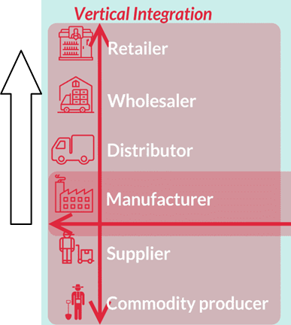 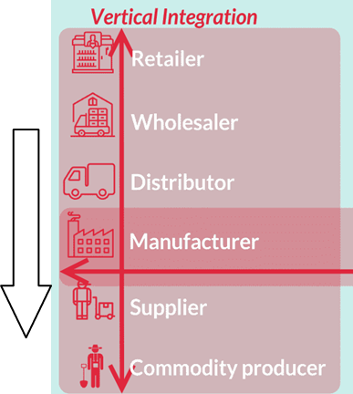

**Conglomeration:**

* **Definition**: A conglomeration refers to a large corporation that consists of diverse businesses, often unrelated to one another, that operate under unified management. Conglomerates are formed through mergers and acquisitions where companies seek to diversify their operations by entering into different industries or markets.

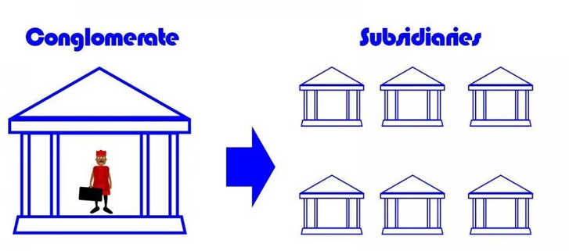

* **Mechanism**:
  + Conglomeration occurs when a company expands its reach by acquiring businesses that operate in different industries or sectors. The acquired businesses may have little to no relation to the company's core business. This approach allows a conglomerate to mitigate risks by diversifying its portfolio of investments and businesses.
* **Example**:
  + **General Electric (GE)** is a classic example of a conglomerate. GE operates in various industries, including aviation, healthcare, renewable energy, and financial services. This diversification allows GE to benefit from multiple revenue streams, making the company less vulnerable to downturns in any single sector.
* **Types of Conglomerate Mergers**:
  + **Product Extension**: When companies merge to expand their product lines into new categories. For example, a food manufacturing company might merge with a beverage company.
  + **Market Extension**: When companies merge to enter new geographical markets or customer bases. For instance, a company in Europe might merge with one in Asia to expand its global reach.

**Advantages of Conglomeration:**

1. **Diversification**:
   * By operating in multiple industries, conglomerates reduce their risk. Poor performance in one sector can be offset by strong performance in another, providing a stable financial base.
2. **Risk Reduction**:
   * Conglomerates are less vulnerable to market fluctuations in individual industries. If one part of the business experiences a downturn, other parts may continue to thrive, balancing the overall risk.
3. **Capital Allocation**:
   * A conglomerate has more flexibility in capital allocation. It can divert resources from low-performing sectors to more profitable areas, allowing it to maximize returns on investment.
4. **Economies of Scope**:
   * By sharing resources, such as research and development or marketing capabilities, across various business units, conglomerates can achieve economies of scope, reducing costs and improving efficiency.

**Disadvantages of Conglomeration:**

1. **Complex Management**:
   * Managing a conglomerate can be challenging due to the diverse nature of its businesses. Each sector may require different expertise, making it harder to maintain operational efficiency and cohesive leadership.
2. **Lack of Focus**:
   * Diversifying into unrelated industries may lead to a lack of focus on the core business. The company might spread its resources too thin, resulting in decreased performance in its primary markets.
3. **Risk of Overextension**:
   * Conglomerates may become too large and complex to manage effectively. When one division of a conglomerate fails, it can negatively impact the entire company's performance, as resources may be tied up in underperforming units.
4. **Potential for Conflicts of Interest**:
   * Conglomerates may have political or financial interests that influence their decisions, particularly when it comes to government policies or regulations that benefit their various divisions. As a result, they may be less inclined to criticize or challenge governments that align with their business interests.

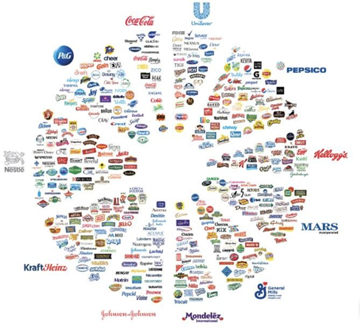

**THE DIFFIRENCE**

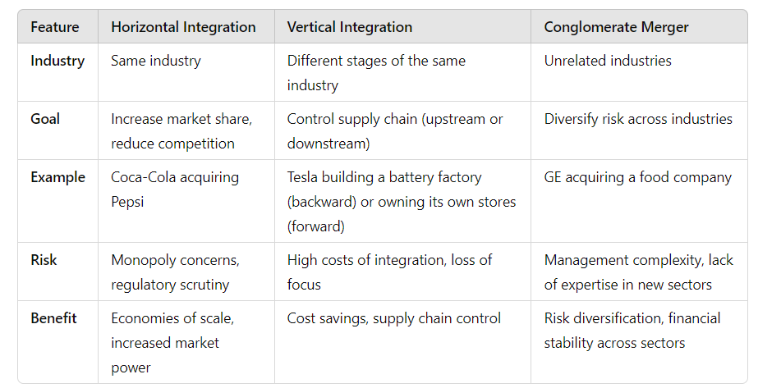

**Key Elements of Global Market Integration:**

According to Smith, it was no longer a question of teaching mankind what must be done with reference to the next world, but rather of understanding what the human being actually is and what can be done in this world with humans as they actually are. The social contract and the workings of society should be studied on the basis of natural humans (Bouchet: Adam Smith: Then & Now).

1. **Price Convergence**:
   * Global market integration occurs when price differences across countries decrease as markets align. When trade barriers (like tariffs, transportation costs, or institutional differences) are reduced, the same products become similarly priced across countries.
   * For example, as transportation becomes cheaper or innovations reduce production costs, products that were once expensive to import become more accessible globally, bringing prices in different regions closer to each other.
2. **Reduction of Trade Barriers**:
   * **Trade Costs**: Costs associated with transporting goods, imposing tariffs, or maintaining regulatory barriers can prevent global price convergence. As these costs fall, firms can take advantage of price differences and enter new markets.
   * **Technological Advancements**: Innovations that lower the cost of production and distribution, such as advances in logistics or new communication technologies, help bring down trade costs, fostering integration.
   * **Policy Changes**: Over the 20th century, trade policies like lowering tariffs and signing free trade agreements (e.g., NAFTA, EU) have accelerated global integration by allowing the free flow of goods and services.
3. **Institutional Differences**:
   * Even when tariffs and transportation costs are minimized, institutional differences between countries can still hinder full integration. These differences may involve varying regulations, property rights, legal frameworks, and cultural norms that affect how businesses operate.
   * For instance, differences in religious or cultural regulations, like those involving **halal** certification for food products in Islamic countries, can prevent seamless market integration.
   * Eliminating these institutional barriers, or harmonizing legal and regulatory systems, is crucial for achieving complete integration.
4. **Multinational Corporations and Investment**:
   * Large corporations play a significant role in global market integration by choosing to invest in countries with favorable economic conditions. Governments may incentivize investment by reducing taxes or loosening regulations, which further drives market convergence.
   * However, this competition for foreign investment can lead to a "race to the bottom" where countries sacrifice important social programs, welfare benefits, or environmental protections to remain competitive in the global market.
5. **Globalization and Economic Policy**:
   * Global market integration shapes not only economic policies but also political strategies. Governments often adopt economic policies aimed at maximizing their country’s integration with global markets to attract investments and stimulate growth.
   * This focus on market-driven policies can sometimes lead to reductions in public services like education and healthcare, as countries aim to remain globally competitive by keeping costs low.
6. **Harmonization of Institutions**:
   * To achieve full market integration, countries must harmonize their institutional frameworks, including legal systems, taxation policies, and regulatory standards. Differences in labor laws, environmental standards, and product regulations can create friction in cross-border trade.
   * Some economists argue that global markets will naturally drive this harmonization, as countries adjust their institutions to attract global capital and investments. For example, countries may lower corporate taxes or streamline regulations to align with international standards.

**Implications of Global Market Integration:**

1. **Economic and Social Consequences**:
   * **Increased Competition**: As barriers fall, firms must compete on a global scale, which can lead to greater efficiency and innovation but also poses challenges for local industries that cannot keep up.
   * **Concentration of Wealth**: While global market integration can spur economic growth, it can also exacerbate income inequality as wealth becomes concentrated in core markets or dominant multinational corporations.
   * **Regulatory "Race to the Bottom"**: Countries may reduce regulations or cut taxes to attract investment, which can lead to the erosion of social services and labor protections.
2. **Political and Strategic Changes**:
   * Governments become more focused on aligning domestic policies with the needs of the global market, often prioritizing economic interests over social welfare. This can shift political agendas towards deregulation, lower corporate taxes, and market-friendly policies.
   * As a result, citizens and consumers might experience fewer protections, and public services could become underfunded as governments prioritize integration over other national interests.

**STUDY WELLL**

**GL SA EXAM**